Skincare Career Pack

The Flori Roberts Skincare Career Pack has everything to promote healthy skin from start to finish. This kit contains products for every skin type so your skin will look younger and feel fantastic.

Fresh Foaming Cleanser

Benefit Statement: Soybean, Apricot and Spearmint extracts work together in this stimulating and invigorating cleansing gel to remove oil, makeup and impurities without those harsh drying agents. Fragrance, oil, paraben and gluten free.

Did You Know: Soybean Oil, with a high concentration of Vitamins A, E and K, and Apricot Kernel Oil, which contains a high concentration of Vitamin E, work together to stimulate the synthesis of collagen and elastin so skin retains suppleness, elasticity and clarity.

Skin Types: All skin types

How to Use: Apply to wet face and gently work into lather. Rinse thoroughly with warm water. Avoid contact with eyes. If contact occurs, rinse thoroughly with water.

Double O Complex

Benefit Statement: Keep oily skin under control with Double O Complex. Salicylic Acid, Camphor and Eucalyptus Leaf Oil come together to effectively remove excess oil, dirt, and makeup and leave the skin feeling refreshed and thoroughly clean. Paraben, fragrance and gluten free.

Did You Know: Salicylic Acid helps to break up the cells that hold excess dirt, oil and makeup in your pores. And it is a powerful exfoliator that helps to remove dead, dry skin while reducing inflammation to prevent future breakouts.

Skin Types: Combination, oily skin types

How to Use: After cleansing, saturate cotton pad with Double O Complex and apply in small circular motions. Extra oily skin types may want to reapply with fresh cotton pad until cotton pad wipes clean.

Ultimate C Clarifying Toner

Benefit Statement: An alcohol-free toner enriched with Vitamin C and a blend of Lemon and Grapefruit extracts that protect the skin against signs of aging. Ultimate C Clarifying Toner softens and smoothes the skin while brightening for a luminous clarity. Paraben and gluten free.

Did You Know: Citric Acid invigorates the skin, removing dead cells that build up throughout the day and night. It cleanses and purifies the skin naturally, without leaving a stripped or dry feeling.

Skin Types: All skin types

How to Use: After cleansing, saturate cotton pad with Ultimate-C and smooth over face and neck.

Oil-Free Moisturizer SPF 15

Benefit Statement: This ultra-light, oil-free moisturizer with natural oil-absorbing starch, herbal extracts and SPF 15 helps control oil shine while leaving skin feeling smooth and toned. Strengthens and protects the skin against moisture loss without oil, filters out the sun’s harmful rays (both UVA & UVB) and helps prevent future skin damage and uneven coloration.

Did You Know: Regular use of sunscreens over the years may reduce the chance of skin damage and other harmful effects due to the sun. Oil Free Moisturizer SPF 15 filters out the sun’s harmful UVA & UVB rays to prevent future damage and uneven coloration.

Skin Type: Combination, oily skin types

How to Use: Massage a small amount onto clean face and neck until absorbed. Use alone or over your specialty treatment.

My Everything Crème
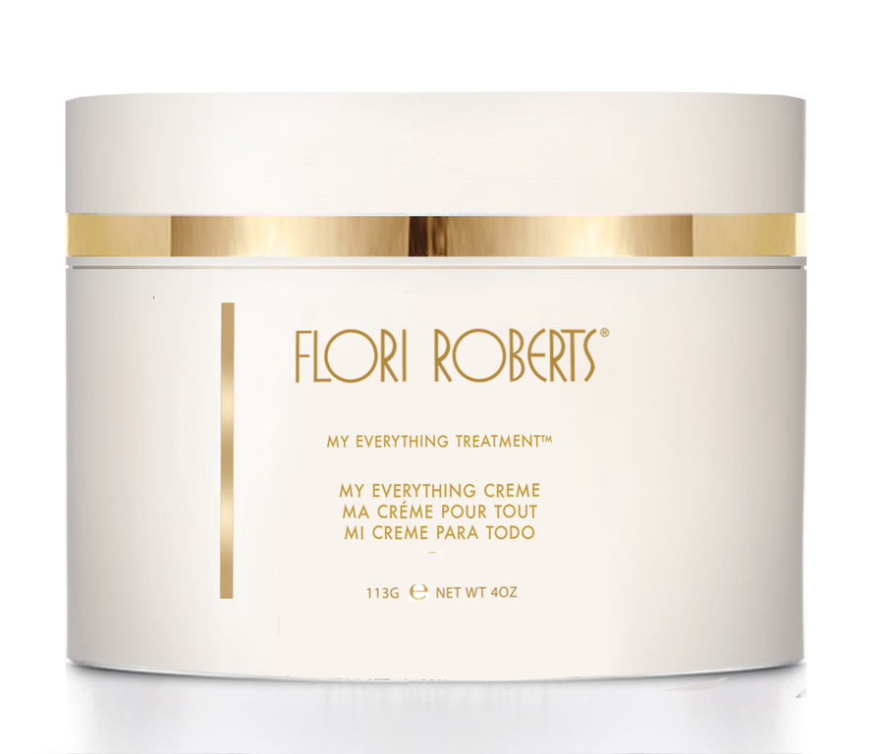
Benefit Statement A rich emollient cream formulated to fortify the skin with dual moisturizing protection day and night. For younger looking skin, My Everything Crème can be worn daily as an eye, throat, face and body cream all in one. Dermatologist tested. Paraben and fragrance free.

Did You Know: My Everything Cream can be used on the face, throat, body and around the eye area day and night. It contains ingredients that serve multiple purposes so you have an all-in-one cream. Hazelnut Seed Oil and Marigold Flower Oil which help to nourish, soothe and soften, Squalene which helps to moisturize and Vitamin A to help increase skin’s elasticity for your softest skin yet.

Skin Types: All skin types

How to Use: Apply to skin with fingertips.

Exfoliating Facial Scrub & Primer

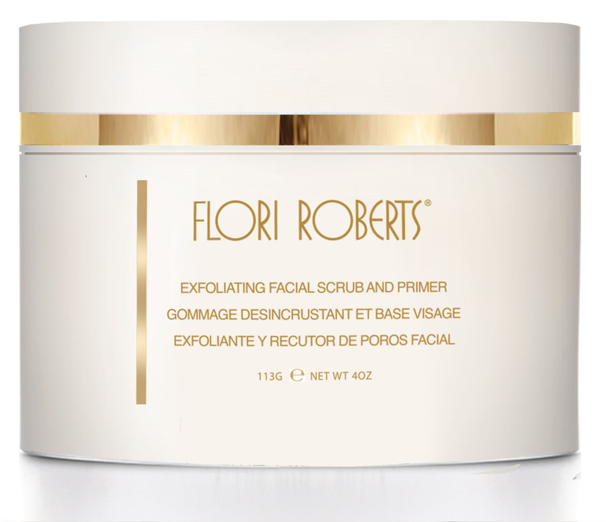
Benefit Statement: Nature’s best blended together in this natural facial exfoliant and primer. Almond, Walnut and Papaya extracts gently exfoliate and melt away dead skin cells. Honey, Wheat Protein and Sweet Almond Oil condition, soften and moisturize the skin. Paraben free. No artificial coloring.

Did You Know: The best time to exfoliate is after cleansing and before toning. This will open the skin up and prime it for your next step. Exfoliating Facial Scrub & Primer contains crushed almonds and walnut shell powder to gently buff away dead skin cells. And, Papain, a papaya enzyme, which is a gentle exfoliating agent that helps to restore the even-tone look of sin by accelerating the process of removing dead skin cells.

Skin Types: All skin types

How to Use: Gently massage over face. Rinse thoroughly.

