**Color Cosmetics Career Pack**

Your Career Pack includes selected products which are in cartooned so you can see the complete packaged presentation. Have fun showing, demonstrating & taking orders for all of the products which are enclosed.

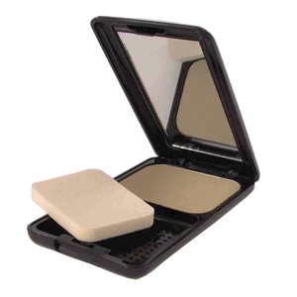

**Perfection Microfine Powder Foundation**

**Benefit Statement:** Highly pigmented, finely milled powder foundation features sheer to full buildable coverage. Dual purpose may be used wet or dry depending on desired finish. Contour, highlighting, set makeup and touchups, Perfection Microfine Powder does it all. Paraben and fragrance free.

**How to Use:** For a sheer matte effect, apply over moisturizer or primer with enclosed sponge, or dust on with powder brush. For full coverage, blend on with damp makeup sponge.

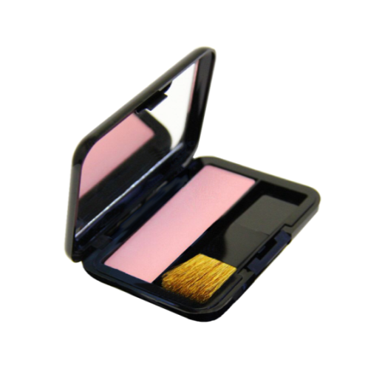

## Color Sense Mineral Blush

**Benefit Statement:** Color Sense Mineral Blush gives you a soft, healthy and radiant glow to flatter any skin tone. Fortified with vitamins A & E to condition skin while providing antioxidant protection. Mineral Blush protects and corrects yet reveals skin's natural radiance. Talc, fragrance, paraben and gluten free.

**How to use:** Apply after powder along the crest of the cheekbone using outward and upward motions toward the hairline. Start with a soft application of color, adding layers for more intense color.

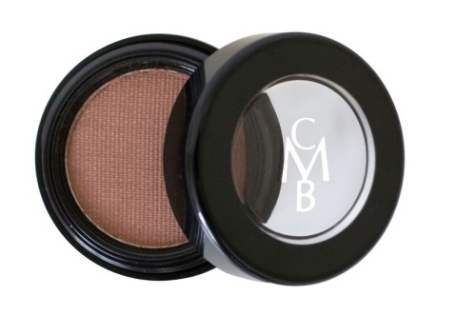**Color Sense Single Eye Shadow**

**Benefit Statement:** New updated, trendier powder colors in a pot. Smooth application with high pigmentation. For best results, use Color Me Beautiful Eye Shadow Base first. Fragrance and gluten free.

**How to use:** To encourage long lasting color for your lids, use over our eye shadow base. Apply the main accent color over the eyelid. Use the darker contour shade in the crease of the eye. A light shade should be used underneath the brow as a highlighter. Then soften and blend away any harsh lines with a make-up sponge.

**Chroma Soft Eye Pencil**

**Benefit Statement:** Soft and creamy pencils for the eye area, enhancing both the color and expression of your eyes. Paraben, fragrance and gluten free.

**How to Use**: Apply after eye base but before applying any eye shadow, line upper and/or lower lids to suit eye shape. Chroma Soft Eye Pencils can be used to create a variety of effects around the eye, from bold to smoldering, soft and natural.

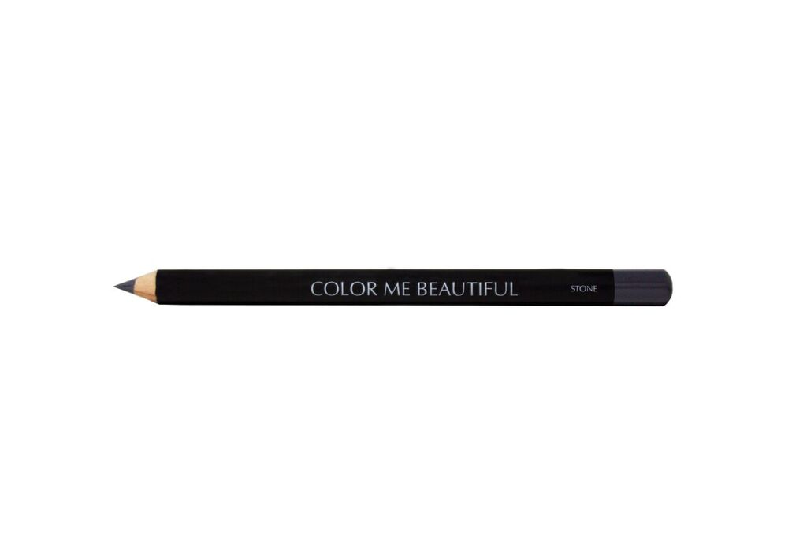

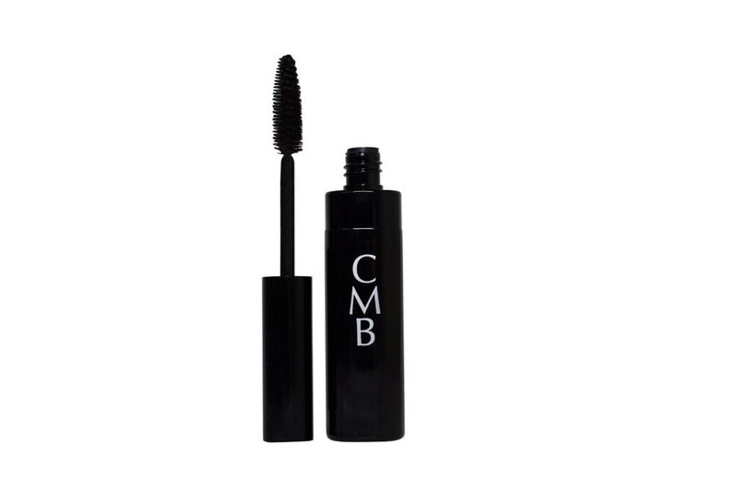

**Sensitive Eyes Mascara**

**Benefit Statement:** Lengthen, separate and darken lashes without clumping or smudging. Sensitive Eyes Mascara’s water-based formula is hypo-allergenic and fragrance free for the most sensitive eyes.

**How to Use:** Apply to clean, dry lashes**.** Use the side of brush to apply to lower lashes first, and then apply to upper lashes. Use the point of the brush for inner and outer lashes.

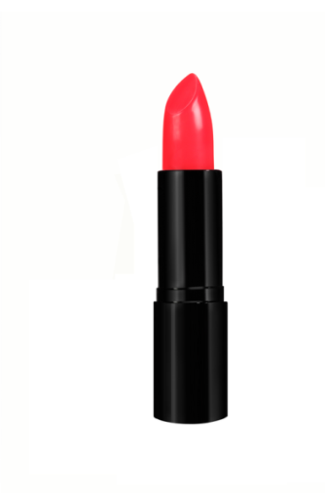

## Color Renew Lipstick

**Benefit Statement:** Color Me Beautiful brings you Color Renew lipstick. The first “melts on your lips” lipstick with self-renewing color spheres. After you apply this buttery cream formula, Color Renew will continue to “renew” your lip color to give that “just applied” look for hours longer. Paraben and gluten free.

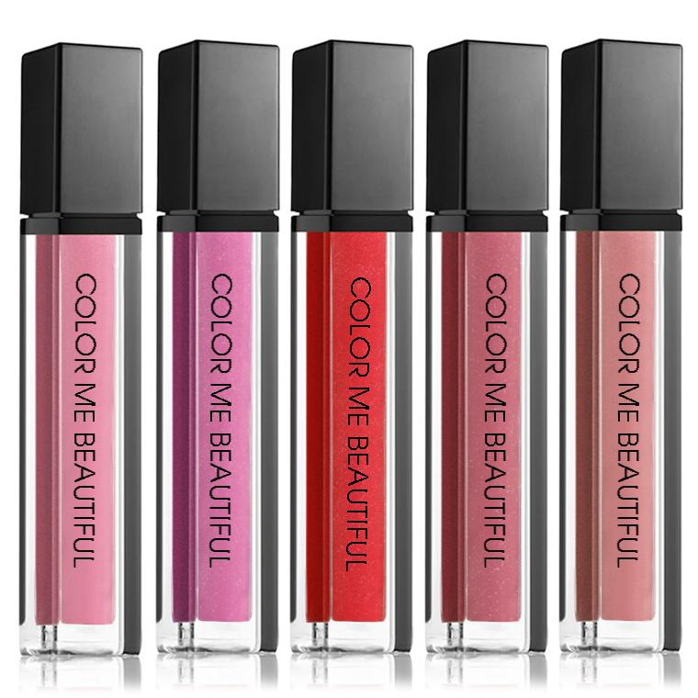

**Mineral Shine Lip Gloss**

**Benefit Statement:** Mineral Base Lip Shine is formulated to provide sheer, dazzling color without stickiness. Made with real, natural minerals for beautiful color and amazingly, super wear-ability. You can wear it alone, after applying lip liner or over another lip shade to add shimmer. Paraben and fragrance free.

**Camouflage Concealer**

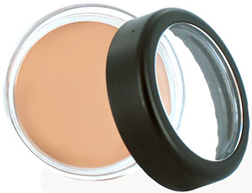**Benefit Statement:** Make dark circles, minor imperfections and discolorations disappear with a touch with our Camouflage Concealer. This creamy formula won’t ever crease or melt. **Fragrance and gluten free.**

**How To Use:** Apply a small amount with synthetic brush, sponge or finger tips to area. Pat and blend lightly.

Use Amber to neutralize the blueish tint that comes from extremely dark circles.

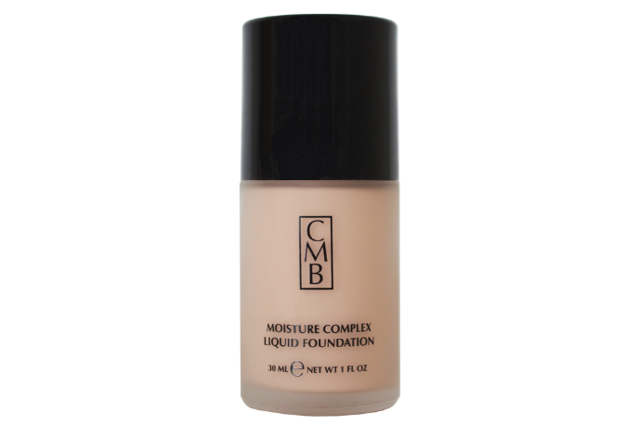

**Moisture Complex Liquid Foundation**

**Benefit Statement:** This water based liquid foundation protects and moisturizes with aloe, sesame and sweet almond oil while collagen and elastin nourish and condition. The result is softer, suppler and hydrated skin. **Paraben free and gluten free**.

**How To Use:** For the most natural look, use a dry sponge (normal to dry skin) or damp sponge (oily skin) to apply foundation in smooth, downward strokes. Blend at jawline.

Waterproof Automatic Eyebrow Pencil

**Benefit Statement:** Looks like a brow pencil, but this is a precision instrument for filling in and shaping up brows, with an easy to use, self-sharpening point. The formula is creamy and smooth with no drag which allows for easy application. The brush end is perfect for softening the application so your brows look beautifully natural. Once set (which takes about three minutes) your brows will look beautiful all day. Fragrance free.

**How To Use**: Apply with light strokes, than blend by brushing through with eye brow brush. Repeat for build-up if desired.

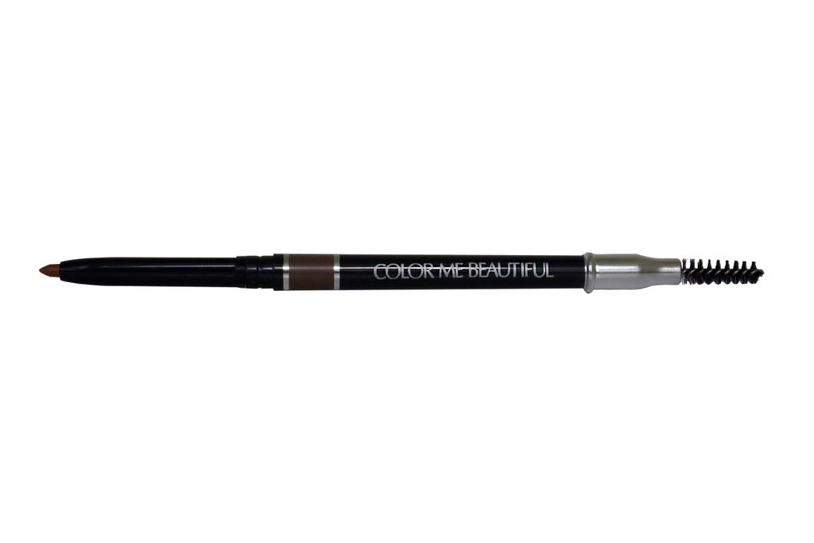

**Color Pro Blush**



**Benefit Statement:** Color Pro Blush is pigment rich and gives you a healthy and radiant glow to flatter any skin tone.  Pigment pure, blendable and easy to layer. This professional quality blush is formulated to makeup artists specifications.

**How To Use**:Apply after foundation and powder. Use Angled Blush Brush and apply to the apples of the cheek. Sweep the excess across the hairline, bridge of the nose and chin. Start with a soft application of color, building up layers depending on the intensity desired.